Grade 7 Accelerated · Unit 3 · Lesson 4  Negative Exponent Law  Question Bank - Additional 3.04 ANSWER KEY | Name  Date  Period

Show your work. Circle your final answer.
For questions 1 through 6, rewrite each expression as an equivalent expression with positive exponents. Do not evaluate.
1. 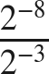
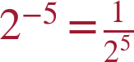 (or )

2. 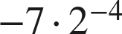
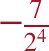

3. 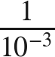


4. 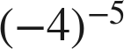
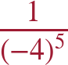

5. 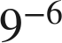


6. 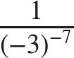


For questions 7 and 8, apply the negative exponent law, then the product or quotient of powers law, and evaluate.
7. Evaluate each expression.
a. 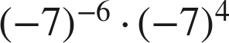
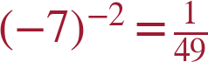
b. 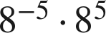

c. 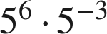


8. Evaluate each expression.
a. 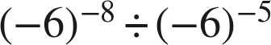
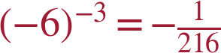
b. 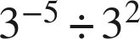
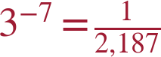
c. 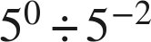


Opposite or reciprocal.
9. Four expressions are shown: , , 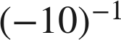, 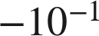.
a. Give the value of each one.
−10; 1/10; −1/10; −1/10
b. Which of the four is the reciprocal of 10, and which is the opposite of 10?
 is the reciprocal;  is the opposite.

Working backwards.
10. Find the value of that makes each statement true.
a. 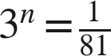
n = −4
b. 
n = −5
c. 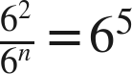
n = −3
2 − n = 5.

11. Which is the value of  ?
● A. 
○ B. 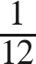
○ C. 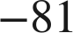
○ D. 
A

12. Select ALL of the expressions whose value is 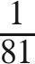.
☐ A. 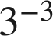
☒ B. 
☐ C. 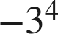
☒ D. 
☒ E. 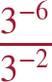
☒ F. 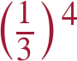
B, D, E and F
E: −6 − (−2) = −4.

